Section 1

Part 1A:

I am interested in keeping my brain sharp so I found an app called Brain Test: Low to High and downloaded it.

https://play.google.com/store/apps/details?id=com.app.brainballbash&hl=en

Part 1B:

Their only real objective is to have people click on ads. There are no in-store purchases to be made, and no calls to action to navigate to their website at all.

Part 1C and 1D:

Keywords:

Brain game

Physics ball game

Brain ball game

Physics brain game

Brain game would have high keyword competition, but Brain Ball Bash ranks low for physics ball game, brain ball game, and physics brain game. The main competitor, Brain It On: Physics Games, has great keywords including the words physics games and brain games. Brain Ball Bash needs to reiterate in it’s keyword usage it is a brain and physics game.

Brain Ball Bash has a chance to break into the top 20 apps using the keywords physics ball game, brain ball game, and physics brain game because right now the top 20 under physics brain games start to include board games and other games which do really not have anything to do with physics.

Section 2

Part 2A:

The other top physics games like Brain It On and Physics Drop utilize the physics keyword well. Brain It On also has over 300,000 reviews with a very high average rating. In their description they also have just 4 bullet points explaining the game and how you play. The user can get a really good idea quickly of what to expect from the game. Brain Ball Bash has a video that is a little long. I also notice when I play Brain Ball Bash there are not a lot of instructions so I found myself wondering what it is I should be doing. Brain It On has simple instructions and is easy to follow and get into. Bran Ball Bash would benefit from a somewhat easier user experience.

Part 2B:

I could not get the downloads or velocity in App Annie without becoming a member.

Brain Ball Bash:

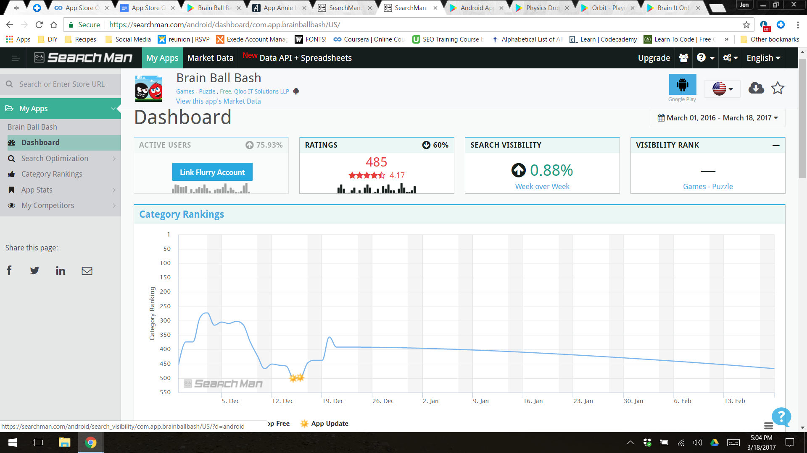

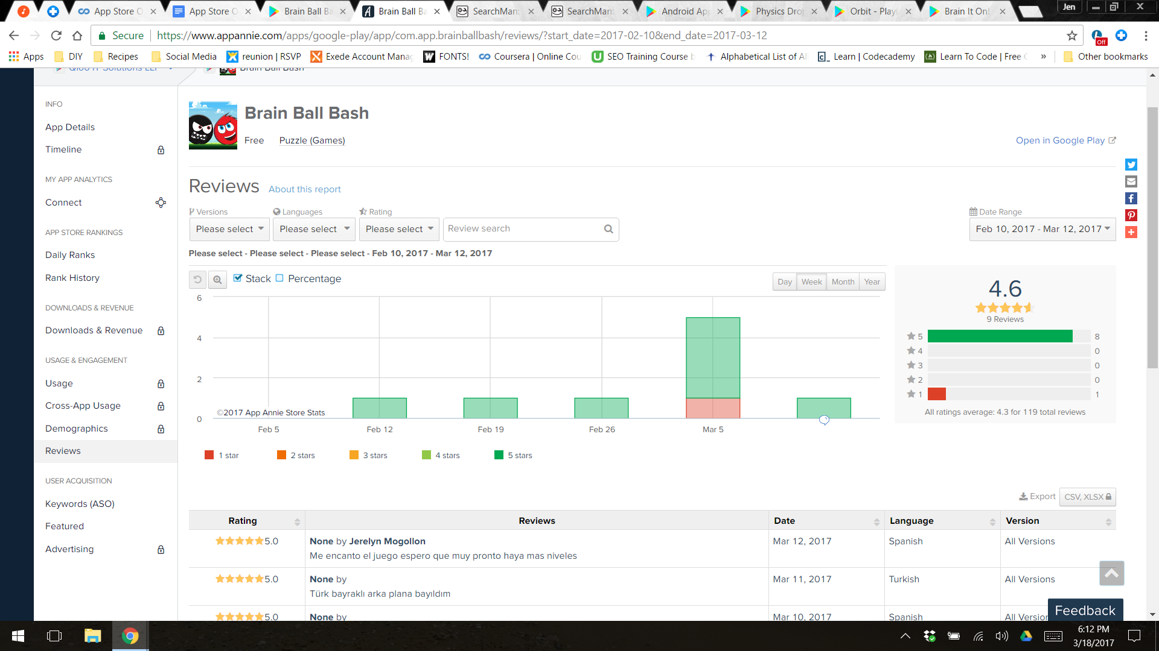

Physics Drop:

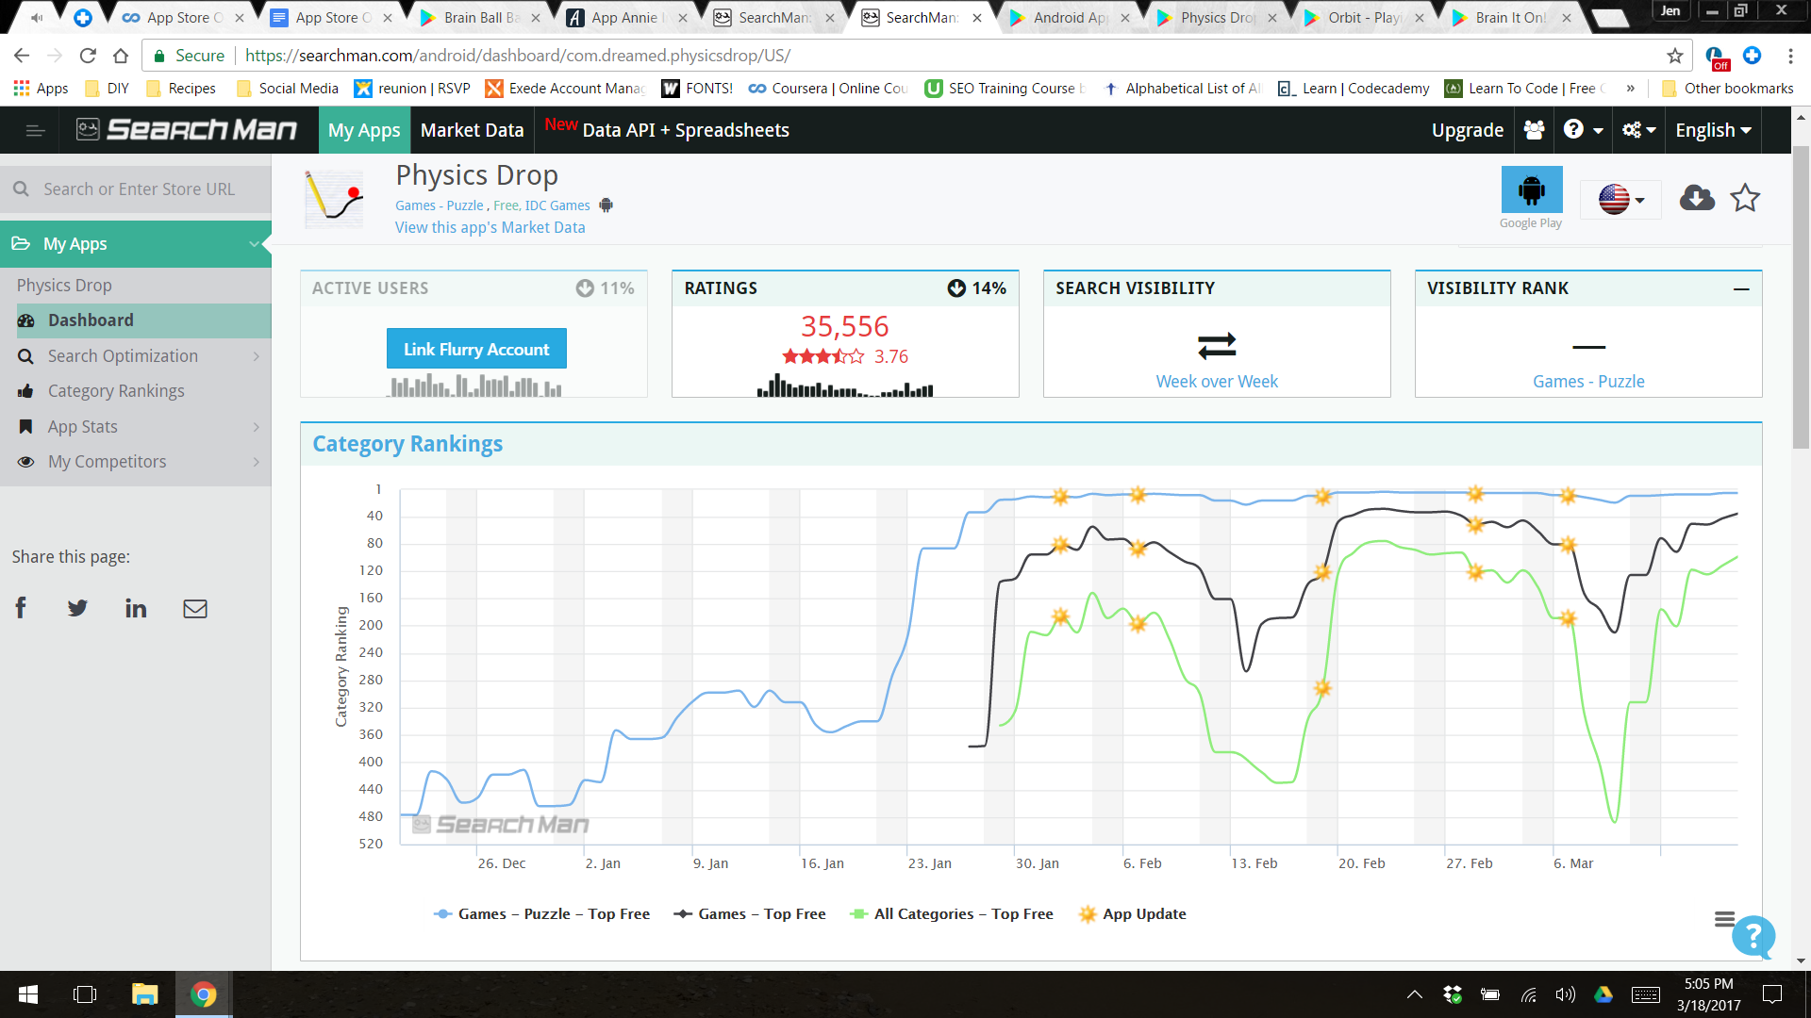

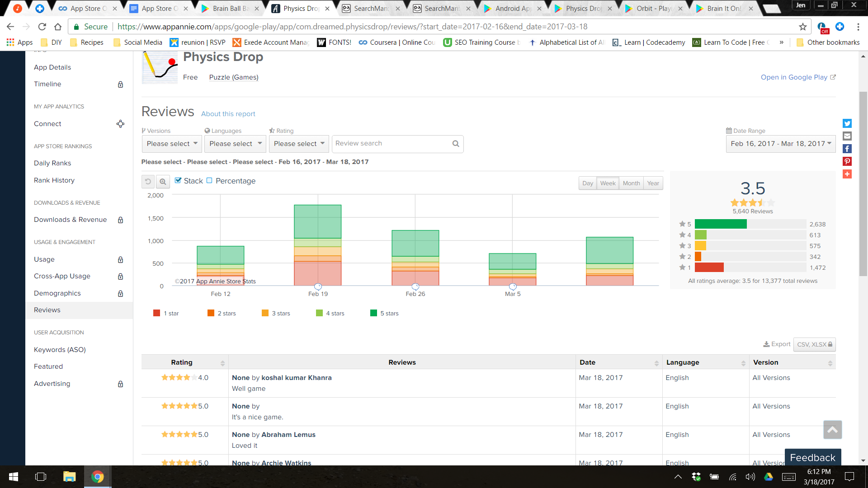

Orbit:

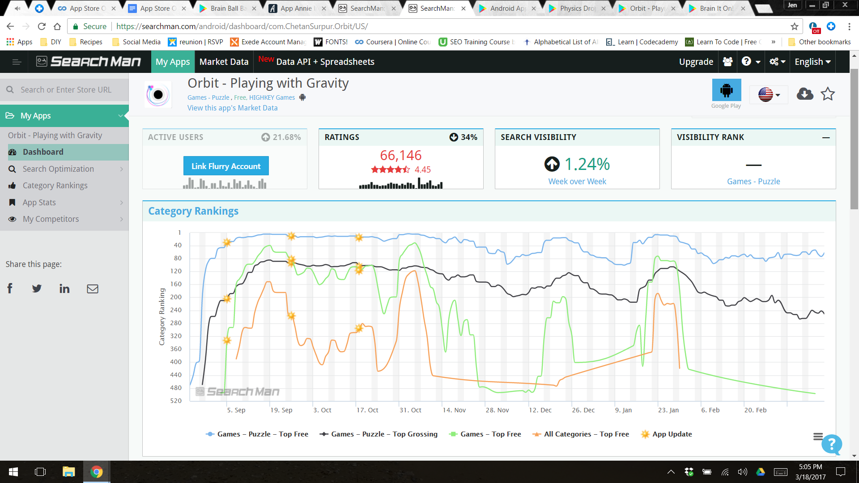

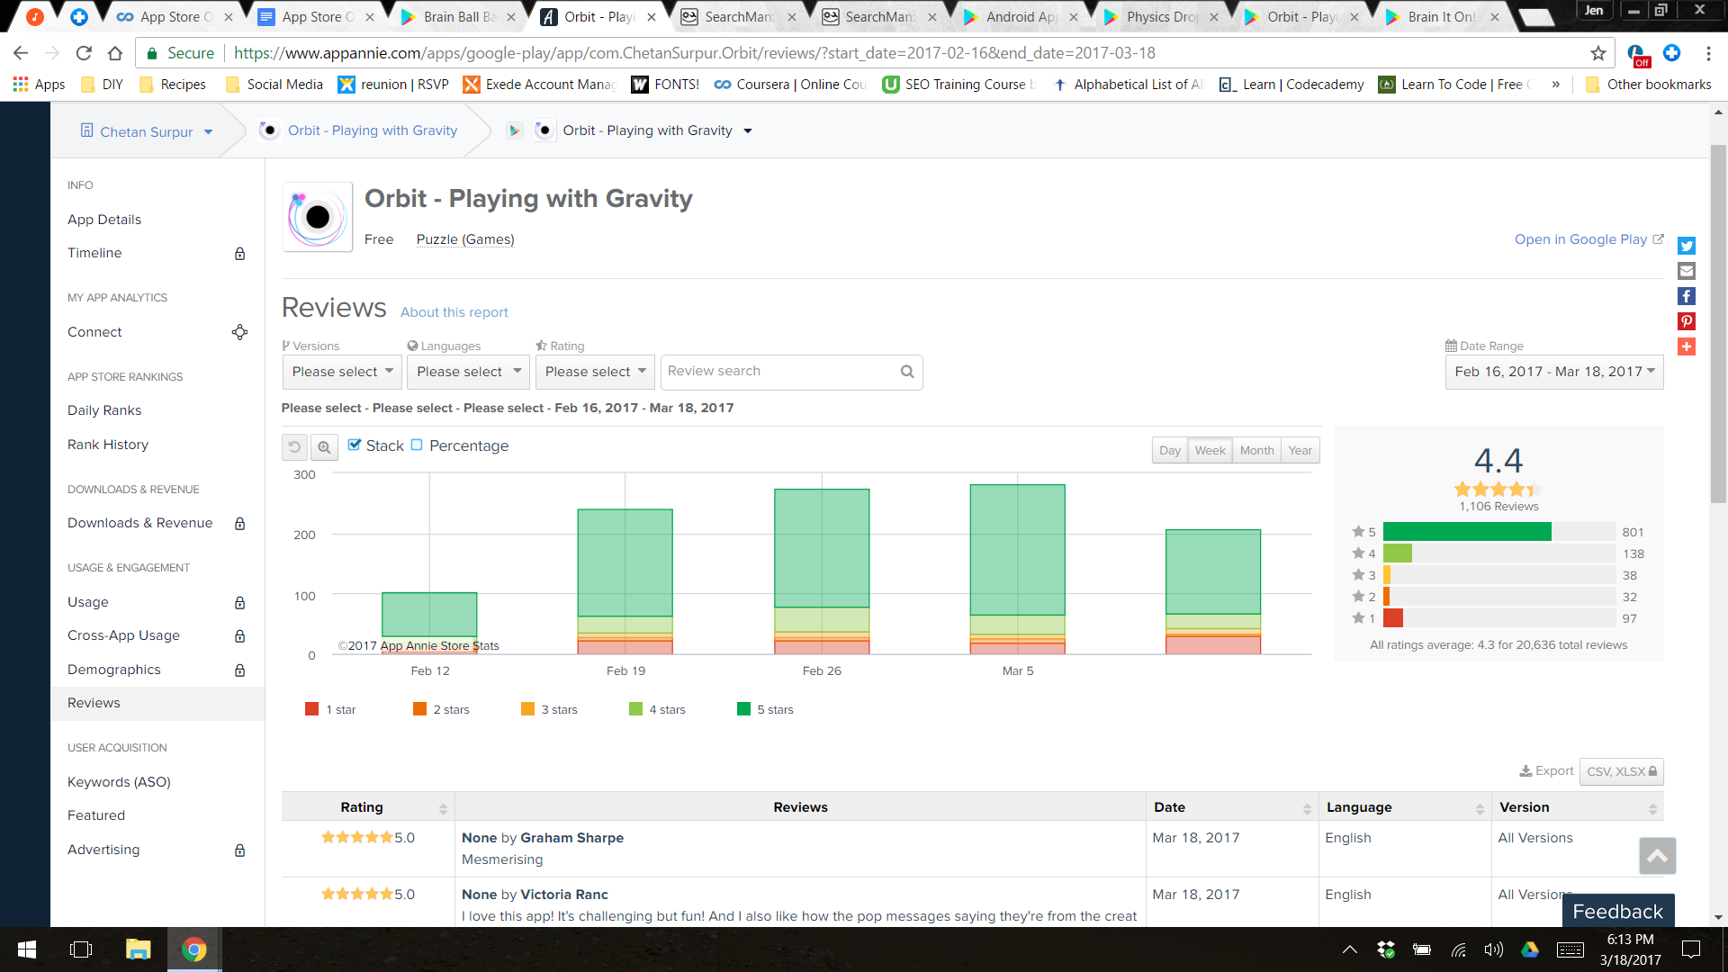

Brain it On!

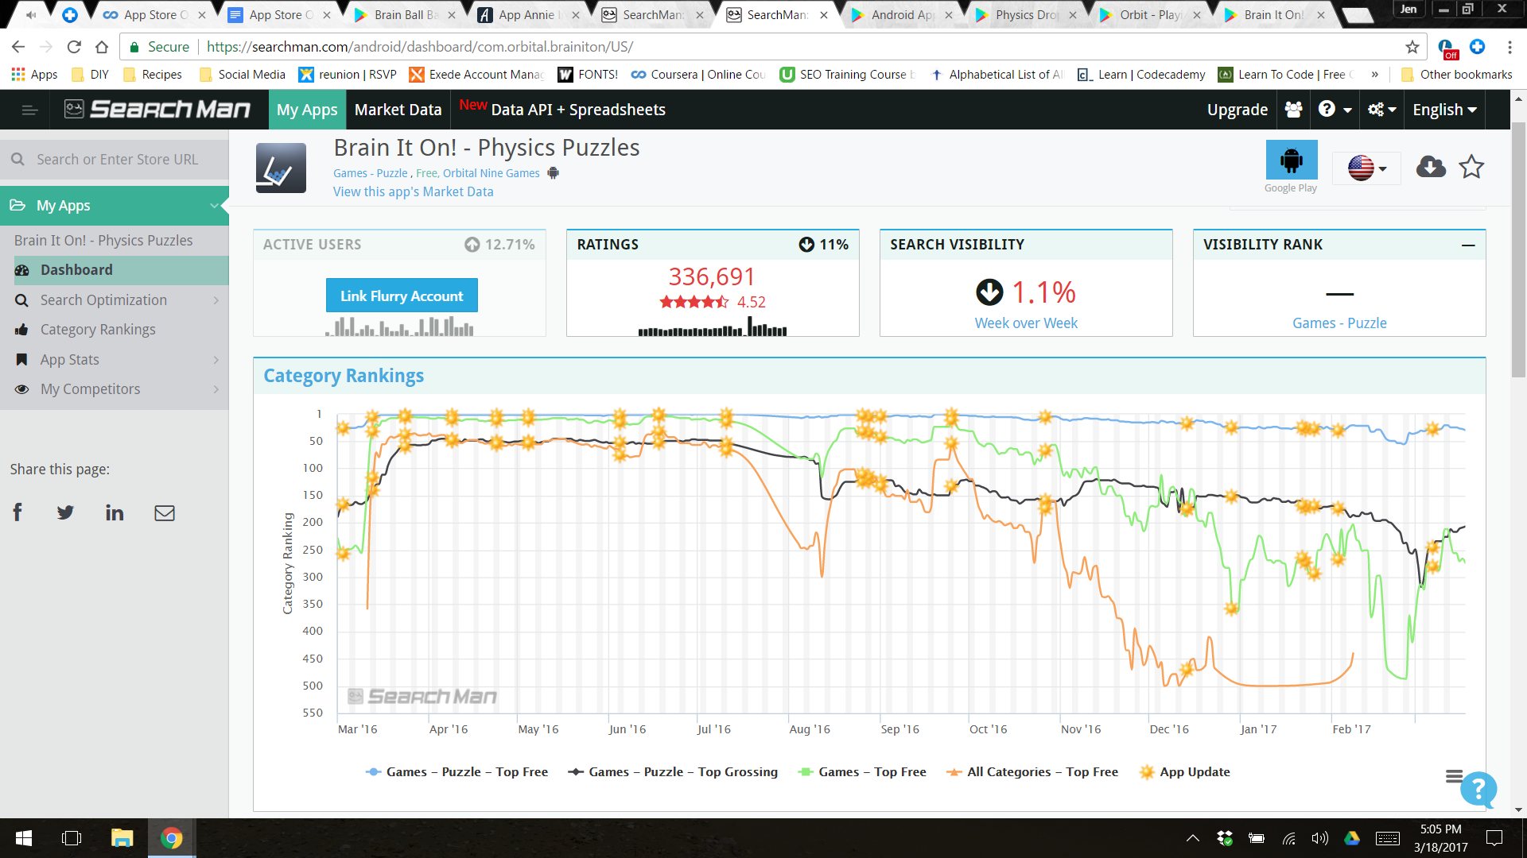

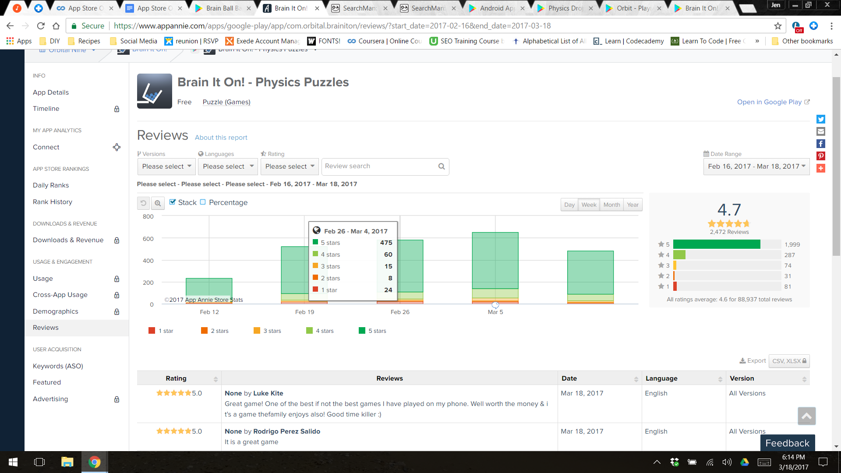

Part 2C:

I chose to compare the category rankings and the description of each app.

Brain Ball Bash:

Description - Brain Ball Bash: Simple & addictive physics based brain ball game. Stretch your mind, draw a line or shape & bump the red and black balls.

Fun, puzzle & war together in this gravity game! More & more challenging levels with beautiful backgrounds for longer entertaining hours.

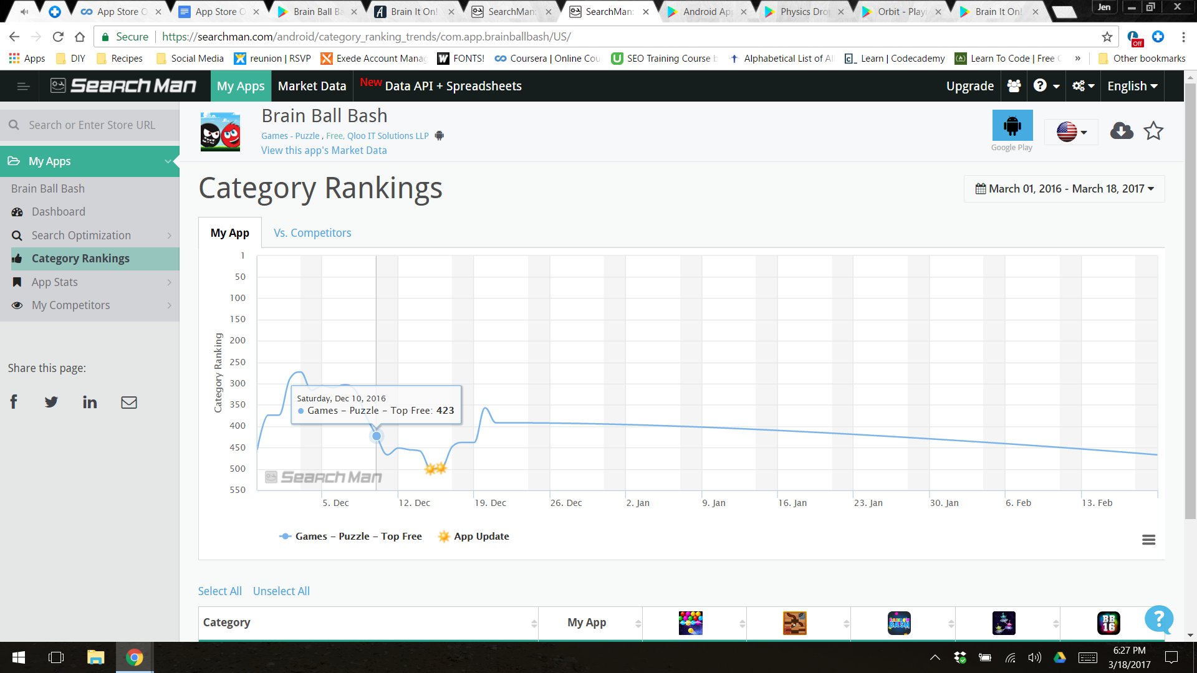

Physics Drop:

Description- Draw as many lines or polygons as needed to gradually make the red ball fall into the U.

Both the ball and the lines react to the law of gravity.

Beware not to trap the ball inside a group of lines!

This educational game features 18 physics problems to solve. If you get stuck, click on the restart button.

Physics Drop is a fun way of practising physics... download it and try!

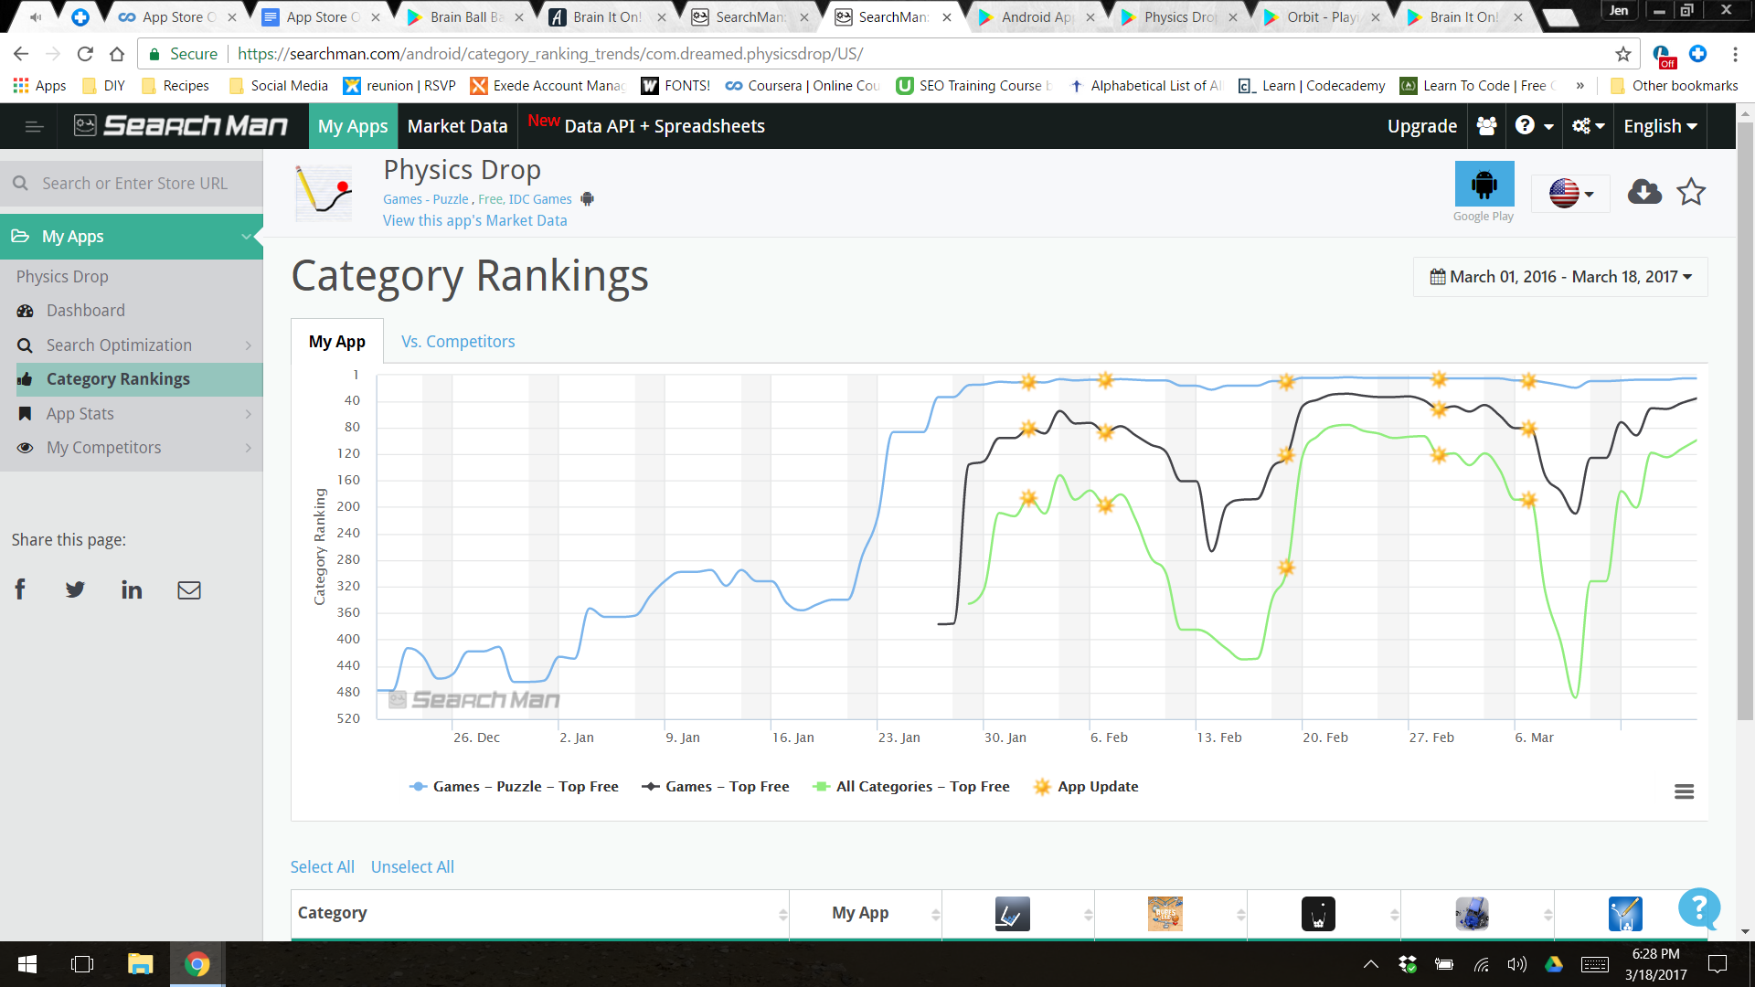

Orbit:

Description- ★ Winner of Google Play Indie Games Festival 2016 ★

ORBIT is a gravity simulator at the heart of a puzzle game. Launch planets with a flick of your finger, and try to get them into stable orbits around black holes.

Can you make enough orbits to progress to the next level?

New: ORBIT now features a Sandbox (premium) where you can create your own levels! Control time, disable collisions, and paint with gravity. Publish your creations to the world for everyone to play.

• 45 free levels, with new mechanics are introduced over time — like repulsive black holes and planets with their own gravity that attract each other

• Play community-created levels — virtually limitless content made by other players, all completely free

• Launch as many planets as you like, and watch the mesmerizing orbital mechanics unfold

• Planets leave colored traces, so that at the end of a level you will have created a beautiful piece of art

• See the future trajectory of a planet before you launch it

• Play in an environment of smooth, minimalist graphics while listening to relaxing classical piano

Follow on Twitter: https://twitter.com/highkeygames

Follow on Facebook: https://www.facebook.com/highkeygames

Note: Upon launch, the game requests permission to access files on the device. This is an optional permission to enable the feature of sharing videos of gameplay (via Everyplay).

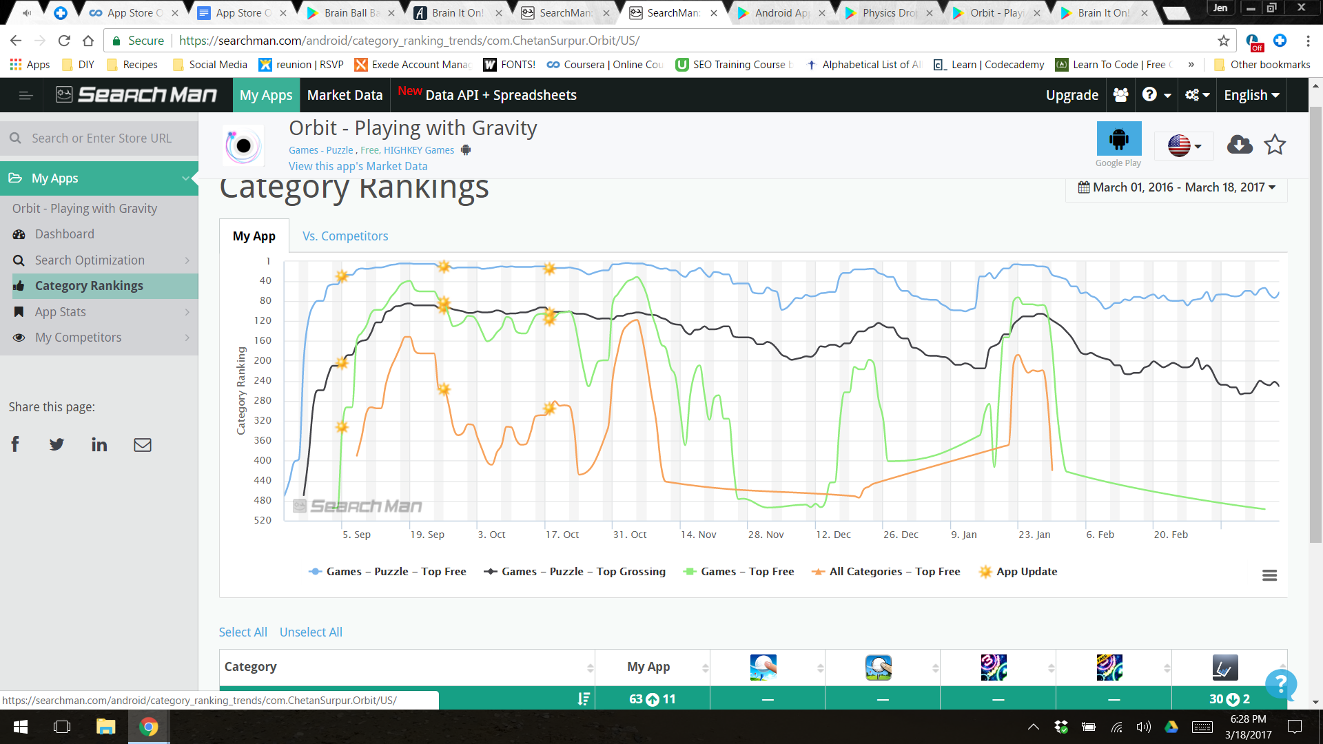

Brain it On!

Description- Deceptively challenging physics puzzles for your brain!

Draw shapes to solve challenging physics puzzles. They're not as easy as they look. Care to give one a try?

◆ Dozens of brain busting physics puzzles, with more being added all the time

◆ Compete with your friends for the Brain It On! crown

◆ Multiple ways to solve each puzzle, can you find the best solution?

◆ Share your unique solutions and compare with your friends

All the levels can be unlocked for free by earning stars in previous levels. You can always find dozens of new player created free levels each day on the community screen. You can also purchase the game to remove all ads, unlock all hints, unlock levels early, and unlock the level editor.

If you like this game, please rate it and leave a comment. As an indie developer your support is greatly appreciated. Thank you for your help! If you don't like something in the game, please email me at support@brainitongame.com and tell me why. I want to hear your feedback and comments so I can continue to make this game better.

You can find me on Twitter at @orbitalnine, see the latest news on the Facebook page at http://www.facebook.com/brainitongame, or get all the details on the website: http://brainitongame.com

I hope you enjoy Brain It On!

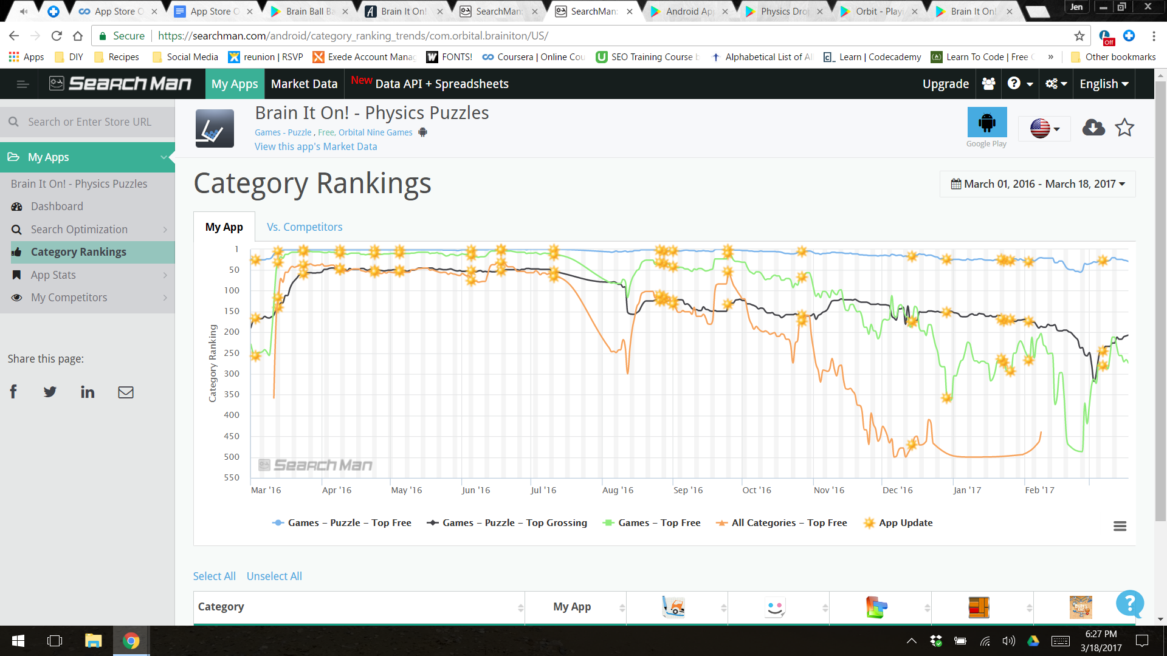

Part 2D: Downloaded the apps.

Part 2E:

It is fairly obvious from the category rankings alone where Brain Ball Bash is struggling. It is only ranking in one category, while it’s competition is ranking in four categories. The descriptions are also a telling point. Brain Ball Bash’s description really does not capture the essence of the game. First of all, it should be marketing itself as a physics ball game, or at the very least a physics game. There is competition with this keyword but not something the app can not overcome. Brain It On! Has a really good description and has four easy to read bullet points which tells the user exactly what they can expect to get out of this app.

The video Brain Ball Bash uses is a little long, and does not show the best parts of the app. The app also does not have enough “training” or instruction and easy rounds because I found myself somewhat stuck on the second level wondering what I am supposed to do next. It is good they have hints on the levels otherwise I would have given up. Brain it On! Tells the player exactly what the objective is which is very helpful

Part 2F:

Week 1: The first thing Brain Ball Bash needs to focus on is marketing itself as a physics game. Keywords including physics ball game, physics brain game, and brain ball game should be easy keywords to get with low competition.

Month 1: After the keywords and better description focus, they need to work on making the app more user friendly and give better instructions. This will help with people giving better reviews.

Quarter 1: The next step needs to be once the app update is ready is to shoot a newer, cleaner, and shorter video which gets to the point of the game then shows all of the cool levels. Most of the video right now is zooming in a dramatic features that don’t add anything to the user wanting to know what the app is about.